# OOP – Environment System

The goal of this lab is to study the **Environment System** and extend its functionality. You are **NOT allowed to directly edit** any of the contents of the **Core** and **Interface** namespaces (only the **Generator** namespace).

## Falling Stars

Who doesn't love stargazing? What's even more beautiful are **falling stars**. Let's make some!

### Step 1 – Falling Star

The **falling star** should pretty much fall in a downward direction. Create a class that models such behavior with an image by choice (e.g. **'O**'). The falling star should **disappear** on contact with the **ground** (assume it's the horizon).

### Step 2 – Star Trails

We're forgetting something though – falling stars have leave **trails**. Modify your falling star so that it leaves a trail of 3 '**\***' while falling.

**Note**: The trail left by the star should be relative to its direction.

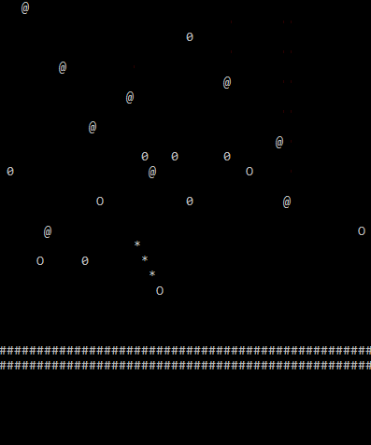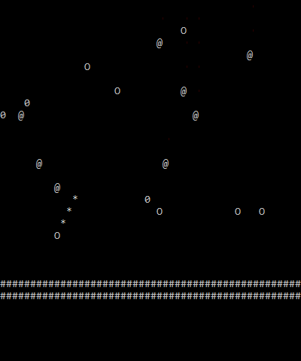

### Step 3 – Make a Wish ☺